# CS 255 System Design Document Template

## UML Diagrams

### UML Use Case Diagram

### UML Activity Diagrams

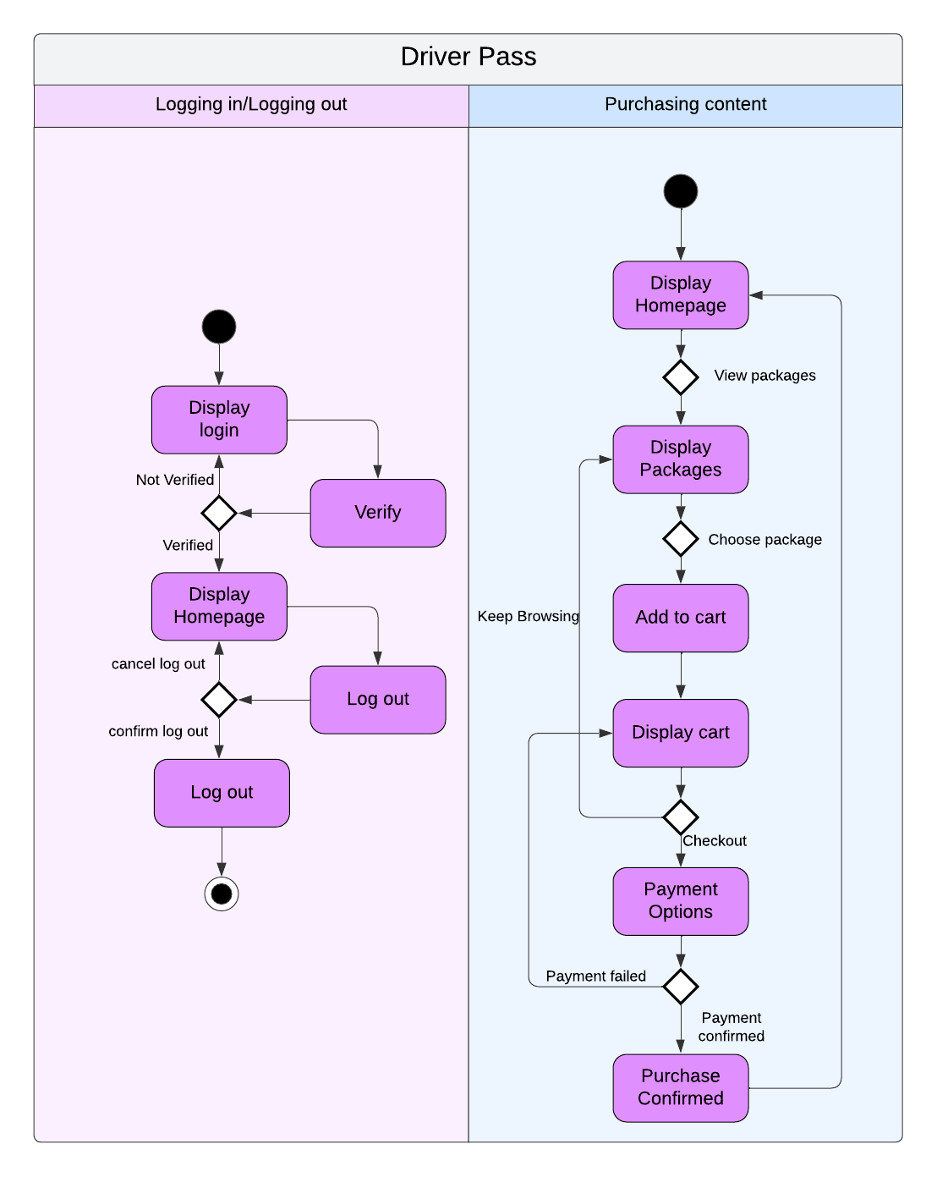

### UML Sequence Diagram

### UML Class Diagram

## Technical Requirements

For the DriverPass system to run, a hosting system will be required. The hosting system needs to be able to host the web app while users access it from their web browsers. To avoid having to maintain the hosting service, the host should be a third-party service. The system will also require a database to store customer information connected to the application, as well as having a verification system for logins. There will need to be a payment portal for customer transactions, as well as a secure database for customer payment information to be stored. The information the system uses as course material will need to be updated regularly, so access to the DMV and their most recent rules and regulations is required.